

**ADDIS ABABA SCIENCE AND TECHNOLOGY UNIVERISTY**

COLLEGE OF ELECTRICAL AND MECHANICAL ENGINEERING

DEPARTMENT OF SOFTWARE ENGINEERING

SYSTEM ANALYSIS AND MODELING (SWENG 309)

Grain-Mill Market and Delivery System

|  |  |  |
| --- | --- | --- |
| No. | Group Members | ID_No |
|  | Ararsa Derese | ETS0152/13 |
|  | Birhanu Worku | ETS0279/13 |
|  | Biruk Mesfin | ETS0290/13 |
|  | Bisrat Kebere | ETS0306/13 |
|  | Biyaol Mesay | ETS0309/13 |
|  | Dagim Tezerawork | ETS0333/13 |

Submission Date:

**February 03, 2023**

**Table of Contents**

**I.** **Introduction** 2

**1.1** **Background** 2

**1.2** **Motivation** 3

**1.3** **Statement of the problem** 3

**1.4** **Objectives** 4

**1.5** **Methods** 4

**1.6** **Scope** 5

**1.7** **Limitations** 5

**II.** **System Requirement Specification** 6

**2.1** **Functional Requirements** 6

**2.2** **Non-Functional Requirements** 8

**III.** **System Requirement Specification** 10

**3.1** **Structured Analysis** 10

**3.1.1** **Data Flow Diagrams** 10

**3.1.2** **Decision Tree** 13

**3.2** **Object Oriented Analysis** 14

**3.2.1** **Static / Structural Models** 14

**A.** **Class Diagram** 14

**B.** **Object Diagram** 15

**3.2.2** **Dynamic / Behavioral Models** 16

**A.** **Use Case Diagram** 16

**B.** **Sequence Diagram** 18

**C.** **Activity Diagram** 19

**IV.** **High Level Architectural System Design** 21

**4.1** **Component Diagram** 21

**4.2** **Deployment Diagram** 22

**4.3** **Package Diagram** 23

**Future Enhancement** 24

**Conclusion** 24

**Appendix** 24

# **Introduction**

## **Background**

Being less digitally advanced has made the market and Ethiopia's development in general difficult. For a long time, many activities in Ethiopia were carried out in an uncomfortable manner in comparison to the industrialized nations. Since then, technology has continued to advance, but not quickly enough to meet the demands, and many issues have persisted despite our attention being drawn to a certain marketing genre, leading us to believe that some of the issues facing the actual world may be partially resolved.

Most commonly in Ethiopia, grain and food powder productions appear to be in unsatisfactory conditions because they are produced by graining raw grains, roots, beans, and other sources, but this production was within village limits where the main raw materials will be sold to the city and also the city will split those raw materials to a different part of the village having small industry to say to produce those food powders required. This is where consumers would buy those raw ingredients and have these tiny factories process grinding and provide them the food powders, but it also needed direct connection with those industries and energy to be squandered on transporting those food powders to the appropriate places. This would irritate both the consumer and the manufacturer. Our response to this problem is to prevent it, if not to enhance the conditions to a satisfactory level.

## **Motivation**

This project is expected to bring more solutions to a portion of the real-world problem we now have. Consumers would no longer have to waste time and energy furthermore; it would no longer be difficult for consumers to get what they acquired from any of the industries they want based on their different judgements like its location and service quality and industries would no longer have to struggle to provide those resources and they would be able to provide their products with schedules. Their working processes would also improve many times over the normal situation. At the end of the day, having a successful solution that solves the problem and advances the growth of the Ethiopian Marketing System is and will always be a right energizer to carry on the process. In other words, humans tend to construct things that are efficient and, over time, improve based on what changes they want to see and make life simpler, which demonstrates the aim of establishing this project.

## **Statement of the problem**

In the absence of an internet system, consumers must verify that they choose the correct product by keeping direct contact with mill companies. The mill firms also do not have a timeframe for when clients will be able to get their products. The STORE may supply one person who may deliver to the consumer's selected location, but there is a price for the more expensive delivery, and because many orders are up to the mill houses, it may be unclear which product is for which consumer if no particular tag is provided to the products. Consumers may also be unclear about which mill house to visit, therefore the mill house they pick may fall short of their expectations, irritating the consumer.

## **Objectives**

This project focuses on solving the problem stated in the problem statement by providing none other than an online system that can, in the best case, solve all of the problems perfectly or, at the very least, solve all of the problems with satisfiable conditions and, over time, improves to make it more efficient. Our major goal with the online system we will design is to save time, money, and increase production and quality while also creating satisfaction on both sides.

## **Methods**

The online system we will create will comprise a website application, desktop, iOS, and Android mobile applications. It will register the user and assign them a unique delivery tag. When ordering, the system asks a series of questions to determine the ideal mill house for them and, depending on the responses, accepts orders from the customer, gives the delivery date, location, and charge information, as well as payment options, and delivers the order to the ideal mill house. For mill firms, the system will register each of them and save service information to compare quality, as well as offer notification when ordered about the order, scheduled day and location of the client with its tag, and remind them to begin promptly.

## **Scope**

The scope of this undertaking is really broad. As its purpose is to make it easier, it is at the very least a national project that will contain a wealth of information about mill firms. As for consumers, it can be used by people of all ages, from young to old, poor to rich, rural to urban, and many more, and thus it can be considered a budget-friendly project that will benefit people from these and other categories. It is improved and evolved to be a comprehensive service that is available throughout our country.

## **Limitations**

Every problem has a solution, and every solution has its limitations, as we realized with our project. As the online system transitions from conventional methods to a more digitalized system, it also necessitates what most technologies presently rely on: the Internet. This online system must connect to servers and have internet connectivity in order for the customer to purchase and get what they want from wherever they are, which might be challenging because some other locations may not have a reliable connection. Furthermore, transportation circumstances may not always be simple, as there may be traffic jams or roads that are not available, and as a result, there may be a delay in the delivery date, which might anger our customers. The uncooperating of the market and mill businesses is another cause and limitation that may exist even at the start of this system, as every firm may not agree with this new approach and therefore may not cooperate with it, which can reduce the number of enterprises as well as the number of consumers. Consumers may be unprepared for the new system; it may provide an easy solution to their problems, but a new process takes time to adapt to, and because the consumers are unfamiliar with the system, it may be ineffective, and the consumer may wish to return to their previous methods of obtaining the required product.

# **System Requirement Specification**

We have devised this project in satisfying the functional, non-functional and Domain requirements by providing the right quantity and quality to the consumers to fulfill their expectations. Following the requirements:

## **Functional Requirements**

1. **User Registration**

When registering for the system, users should be able to provide their name, address, phone number, and email address. The user will be taken to the cart page after making sure all the necessary parameters are met.

1. **Authentication / Log in**

The system should allow users to securely log in with a username and password. A special security code that only the user is aware of must be entered in order to move on to the next page for the user's safety, and if it is accepted, the user will be returned to the cart page.

1. **Add to Cart**

This feature allows users to order or remove items from their shopping cart after logging in. As a result, users are initially directed to the shopping cart page, where they must enter a password to authenticate their identity before the goods may be ordered or removed, depending on their intents.

1. **Product Catalog**

The system ought to offer a thorough catalog of grain items that are offered for purchase, complete with product descriptions, pictures, costs, and availability. From there, the user can continue to order and buy products by adding things to the cart page.

1. **Checkout**

After the user gets all he/she wants In their cart, they precede to the checkout page where the system will automatically add the order to the cart page once the order is submitted, and from that point the user can check the status of their ordered product or change any information if they wish and then precede to payment.

1. **Order and Delivery Tracking**

In order for the consumers to feel comfortable using the system, they will be able to see the order's status at any time after paying for it. From the time an order is placed until it is delivered, customers should be able to follow its progress in real-time.

1. **Payment Processing**

The system should provide safe payment processing using a variety of payment methods, including cash, digital banking, and others, once the product has been selected and the entire cost is known. Additionally, it might surprise you to learn that there will always be promotional discounts available in an effort to boost client happiness.

1. **Reporting & Analytics**

Reports on customer behavior and sales data should be generated by the system so that administrators or other authorized users of the system can utilize them for analysis and decision-making.

1. **Account Setting**

This is where the users personal information can be updates by the user. The user can set a profile picture and update its privacy information.

## **Non-Functional Requirements**

1. **Usability**

Language barriers and localization are necessary to enable users to accomplish work in the languages they understand. The product should promise that there are keyboard shortcuts they may utilize to quickly reach the various pages of this product. The usability can also be determined by how well users can accomplish their objectives, carry out their tasks in the store, whether or not the product's design becomes more recognizable and intuitive over time as a result of repeated use, and, most importantly, by how many mistakes users are likely to make while using the product. In the end, whether or not the system has changed or improved from the ones the consumers are familiar with depends on how they perceive its utilization.

1. **Security**

Dealing with money and sensitive information requires the utmost security. The product should be resistant to all types of attacks, including DDoS and XSS attacks, and the administrator can assign and adjust roles as well as access permissions to the system. Because the product will be storing all activity, it will shut down in the event of a cyber-attack and the administrator will also be reviewing the log entries.

1. **Performance**

Performance should take precedence if our goal is to increase website visitors. The consumer should be satisfied with the online system's performance to the greatest extent possible. The website should fully load in less than 5 seconds when there are more than 20,000 concurrent users, and in less than 2 seconds if there are fewer than 10,000 users, according to standard network conditions. This product supports up to 30,000 concurrent users. The response time for each request should be 10 seconds, and the maximum latency for email delivery should be 12 hours. For visitors who use an LTE mobile connection to view the website, the front-page load time must be under 2 seconds.

1. **Availability**

These programs are cross-platform, which means they are not restricted to a certain operating system or web browser. Also known as the "5 Nines Rule," it will be accessible to users 99.99% of the time. The deployment of a new module must not adversely affect the accessibility of the front page, product pages, or checkout pages, and it must not take more than one hour. The rest of the pages that might encounter issues must present a notice with a countdown indicating when the system will be back up.

1. **Maintainability**

Our primary goal is to make the system simple to maintain from the start. The website will eliminate all back-end complications so that internal developers can modify the system in the future because we want to expand.

1. **Scalability**

The maximum number of visitors to the website must be expandable to accommodate 200,000 users at once. All log entries on the website will be linked to the user who carried out the activity. Scalability should be your focus if you're seeking for a solution that will stand the test of time. This requirement specifies how the website's functionality can develop and increase without degrading its performance. The website can hold 10TB of data, but that amount will grow over the course of six months.

# **System Requirement Specification**

## **Structured Analysis**

## **Data Flow Diagrams**

Data flow diagram depicts the flow of data in and out of Grain Mill Market and Delivery system. For our data flow diagram, we have 3 levels of showing the data flow of the system. In each Level, the data flow is wider and deeper decomposition into the data flow of the system, below we have those 3 levels of the data flow of the system:

**Level 0: Context Diagram**

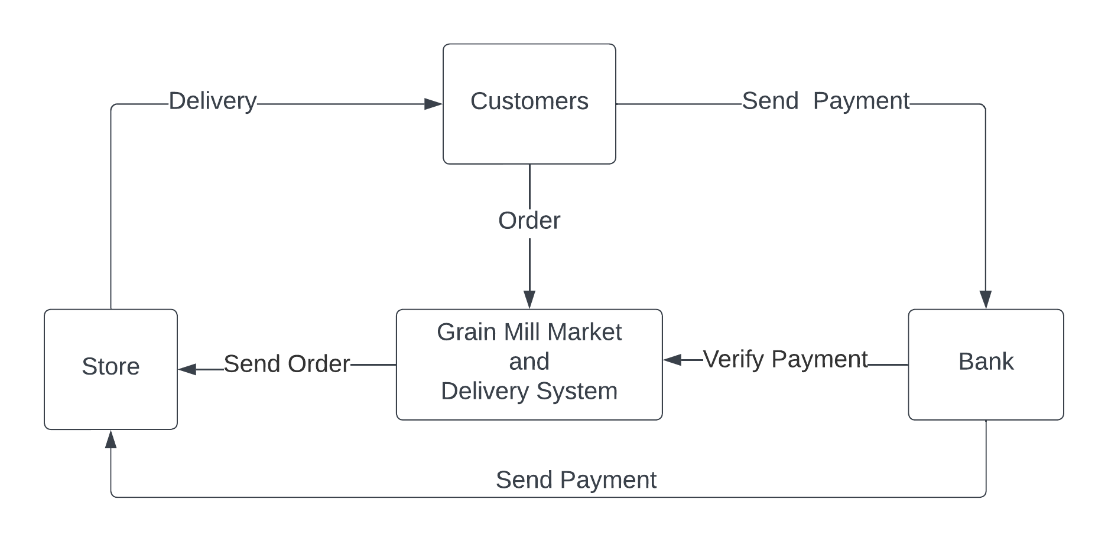

**Level 1: Process Decomposition**

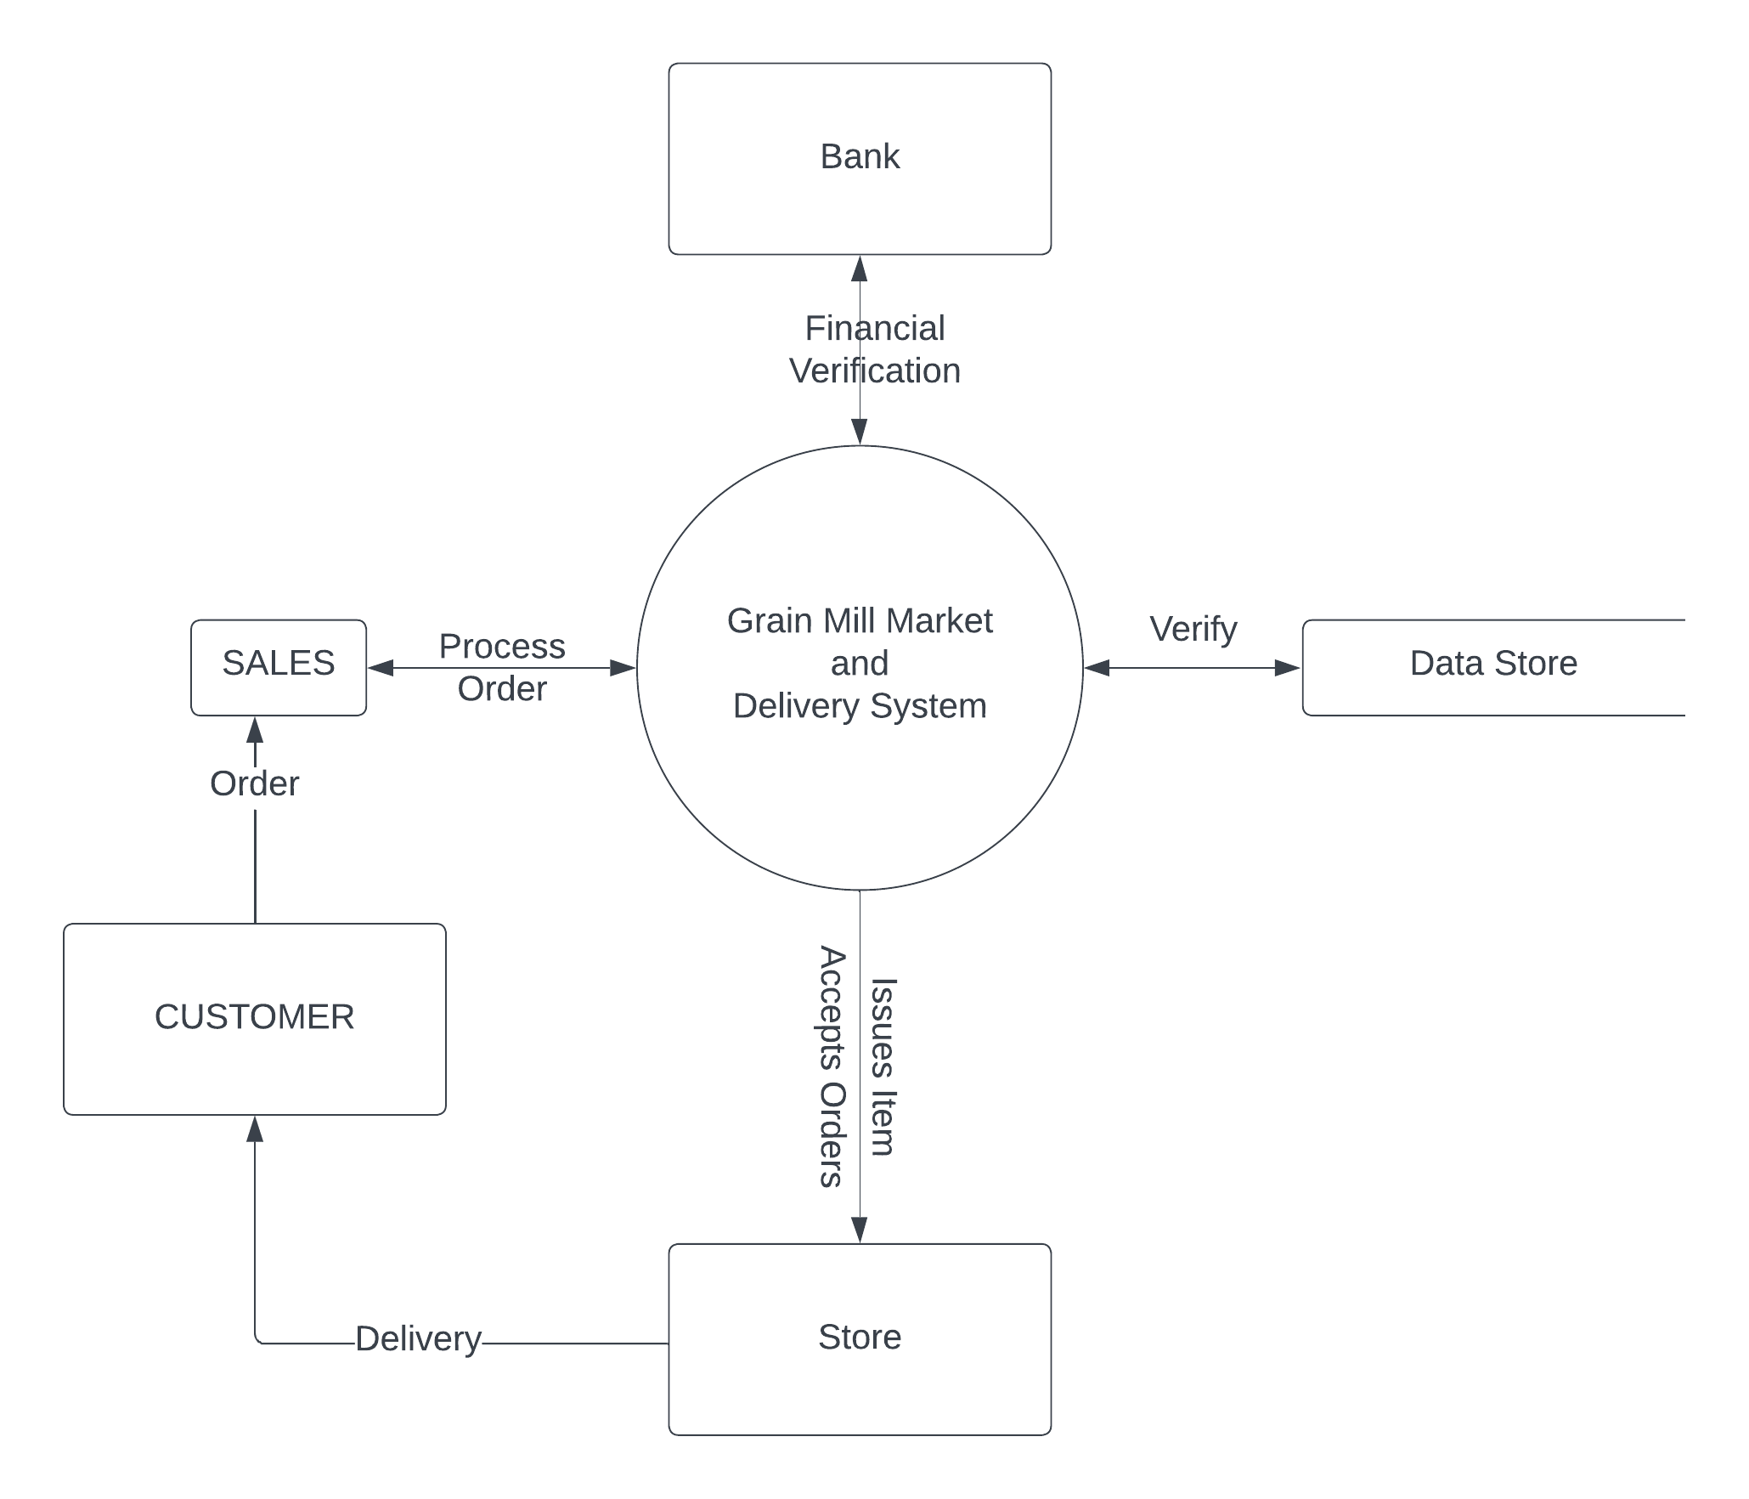

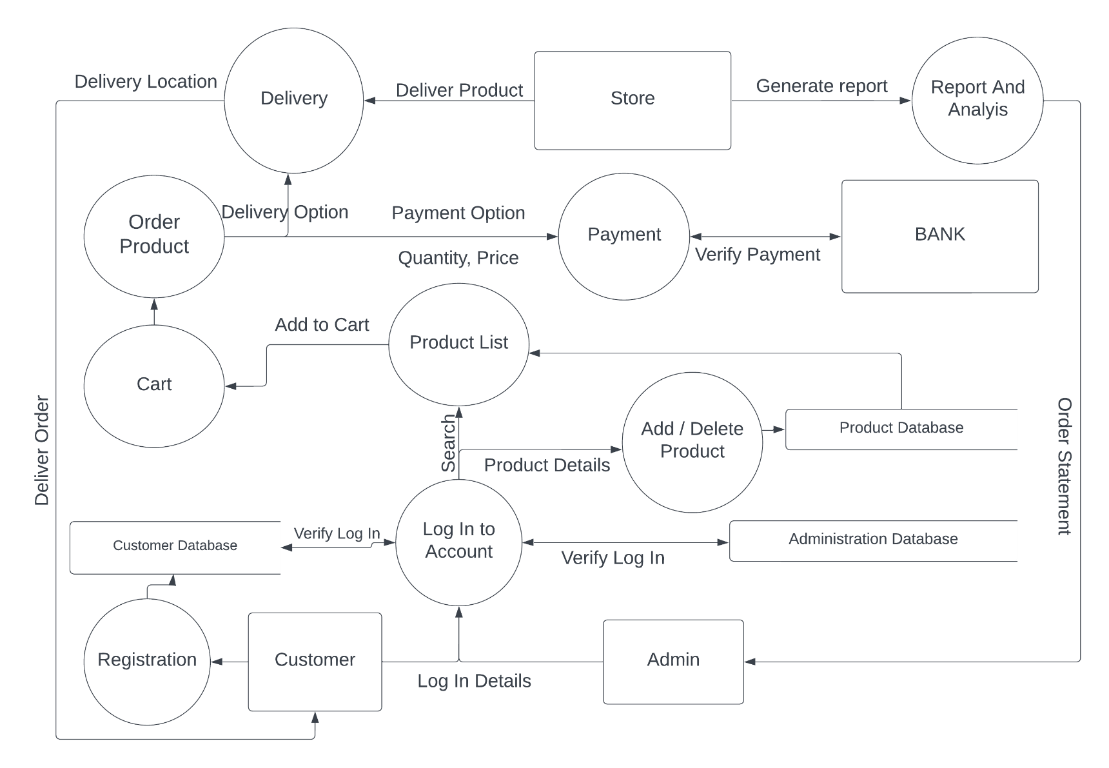**Level 2: Deeper Dives**

* + 1. **Decision Tree**

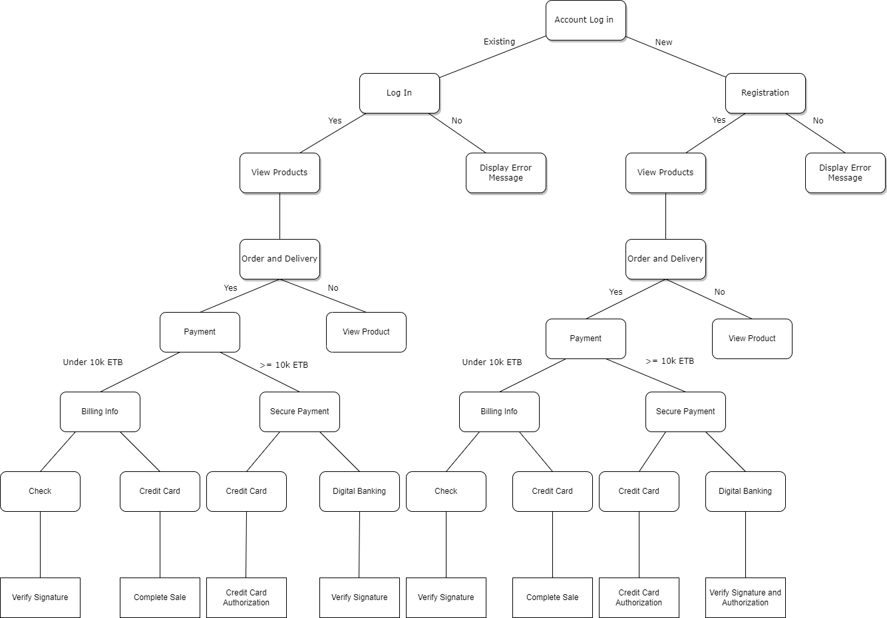

## **Object Oriented Analysis**

## **Static / Structural Models**

1. **Class Diagram**

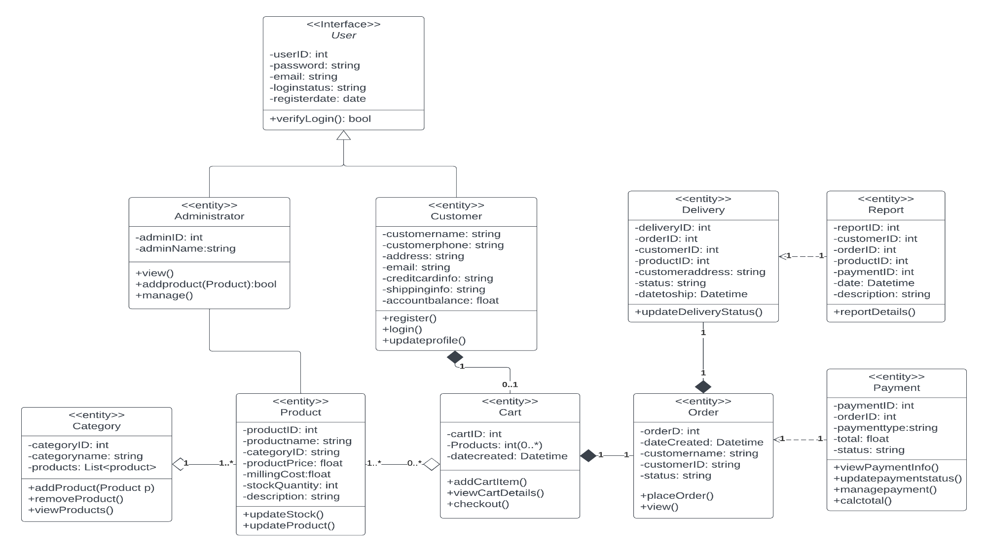

1. **Object Diagram**

The following object diagram shows some instances of classes at a particular time where the user adds different products to his cart from different categories.

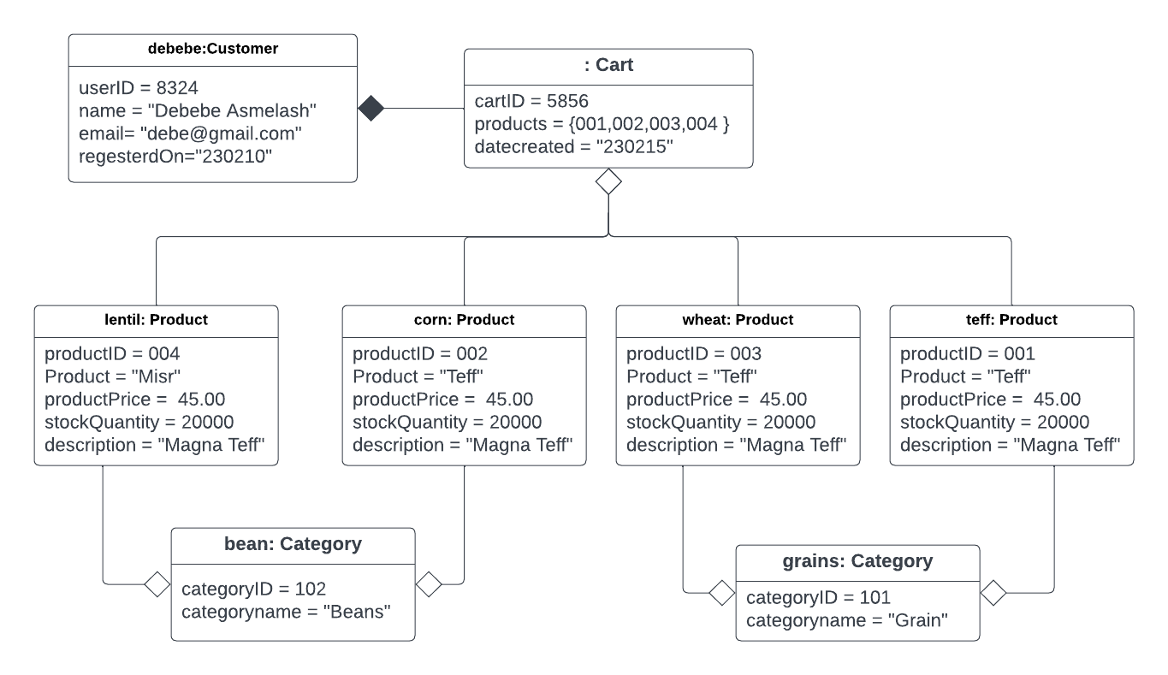

The next one shows different objects of the system when the user completes order of a cart with a product in it with a delivery option included.

## **Dynamic / Behavioral Models**

1. **Use Case Diagram**
2. **Identifying Actors**

As actors, the system is created to interact with the customer for marketing purposes because the customer will launch any business because it is made to serve the customer. Therefore, our primary actor will be the customer, and the admin will respond to all of the customer's product-related issues as the systems secondary actor. Bank also interacts with the system externally.

1. **Identifying Use Case**

If the consumer already has an account, he or she will log in; if not, they will register in order to examine products, and once they have made up their minds to purchase a particular item, they will add the item into their cart and continue to add another until they get all they need. Then, they will precede to place an order by entering both personal and product information. The user will next need to provide any delivery requirements if they want their purchase to be delivered to their doorstep. Once this is done, the user will need to pay using one of the available options, and the order will then be forwarded to the admin for approval. In addition to the primary use case, we will run into extension points where the consumer can modify their profile information and to log out.

1. **Identifying Relationship (Include, Extend)**

As these two functions proceed, they will need to verify if a condition is specified, which is where "include" comes into play; however, if an error message is present, the function needs to extend in order to show that error, which is where "extend" comes into play. The User Registration and Payment will both have included; however, extend will only exist for the User Registration.

1. **Use Case Description In Table Form**

|  |  |  |
| --- | --- | --- |
| Customer | Admin | Bank |
| Account Login | Add / Delete Product | Accept Payment |
| View Product | View Product | Verify Sufficient Funds |
| Order and Details | Order and Details |  |
| Delivery Option | Delivery Scheduling |  |
| Make Payment | Accept Payment |  |

1. **Use Case Diagram Design**

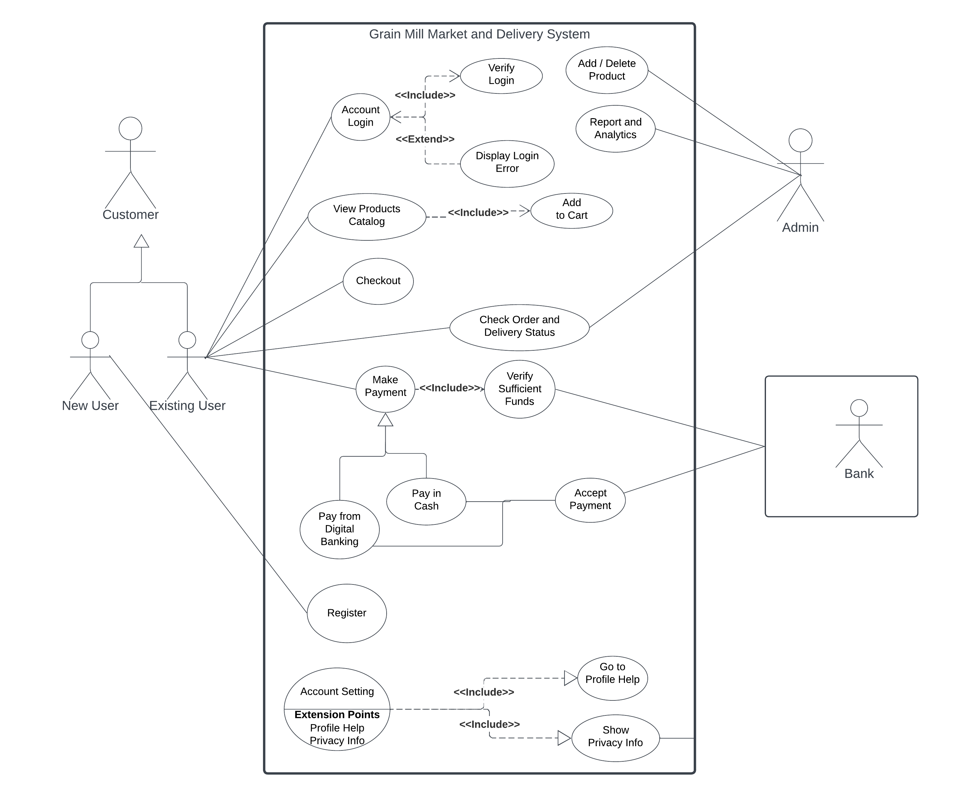

1. **Sequence Diagram**

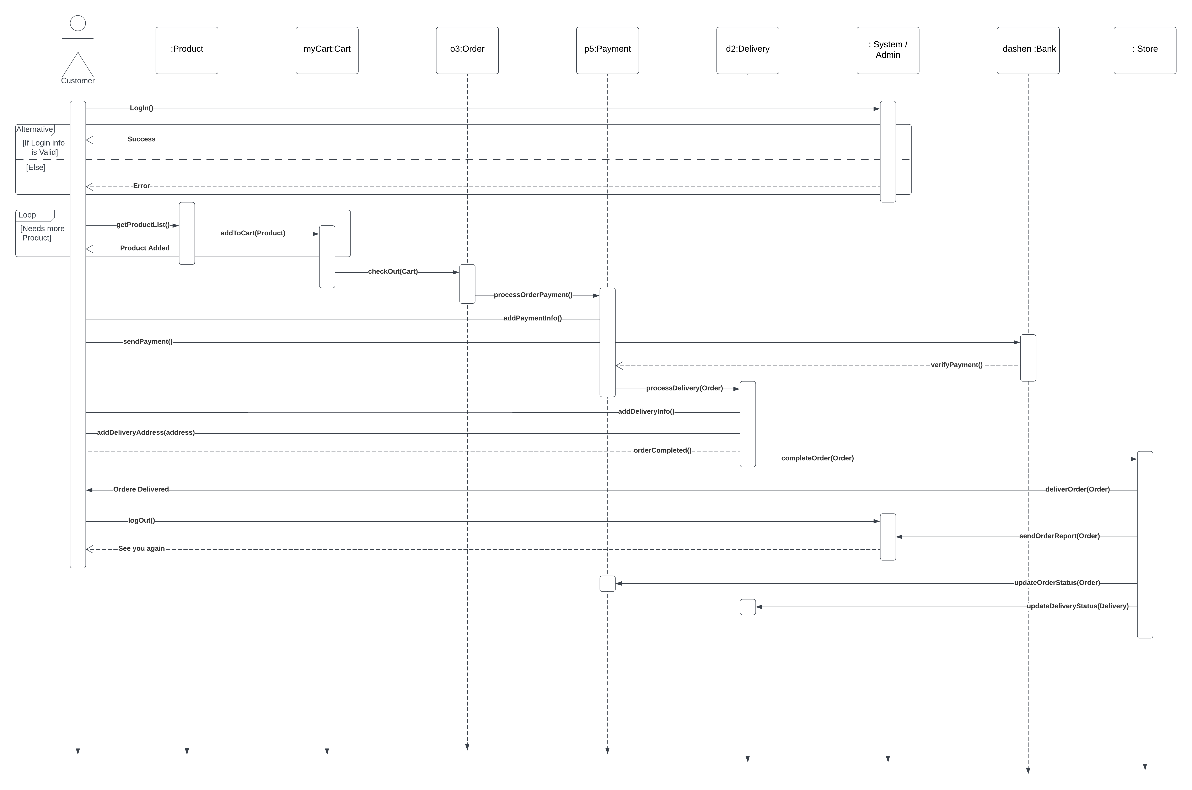 This Sequence diagram shows a typical interaction of a user with Grain Mill Market and Delivery System to order a product.

1. **Activity Diagram**

There are two users particularly making most of the activities in the system, the administrator and the customer. Each of these users has activities that are somewhat similar to and different from one another that are designed with the system, so there may be functions or activities that are different between these two users. For this reason, we have constructed two types of activity diagrams, one for the customer and the other for the administrator, and displayed their activities as follows.

**For Customer**

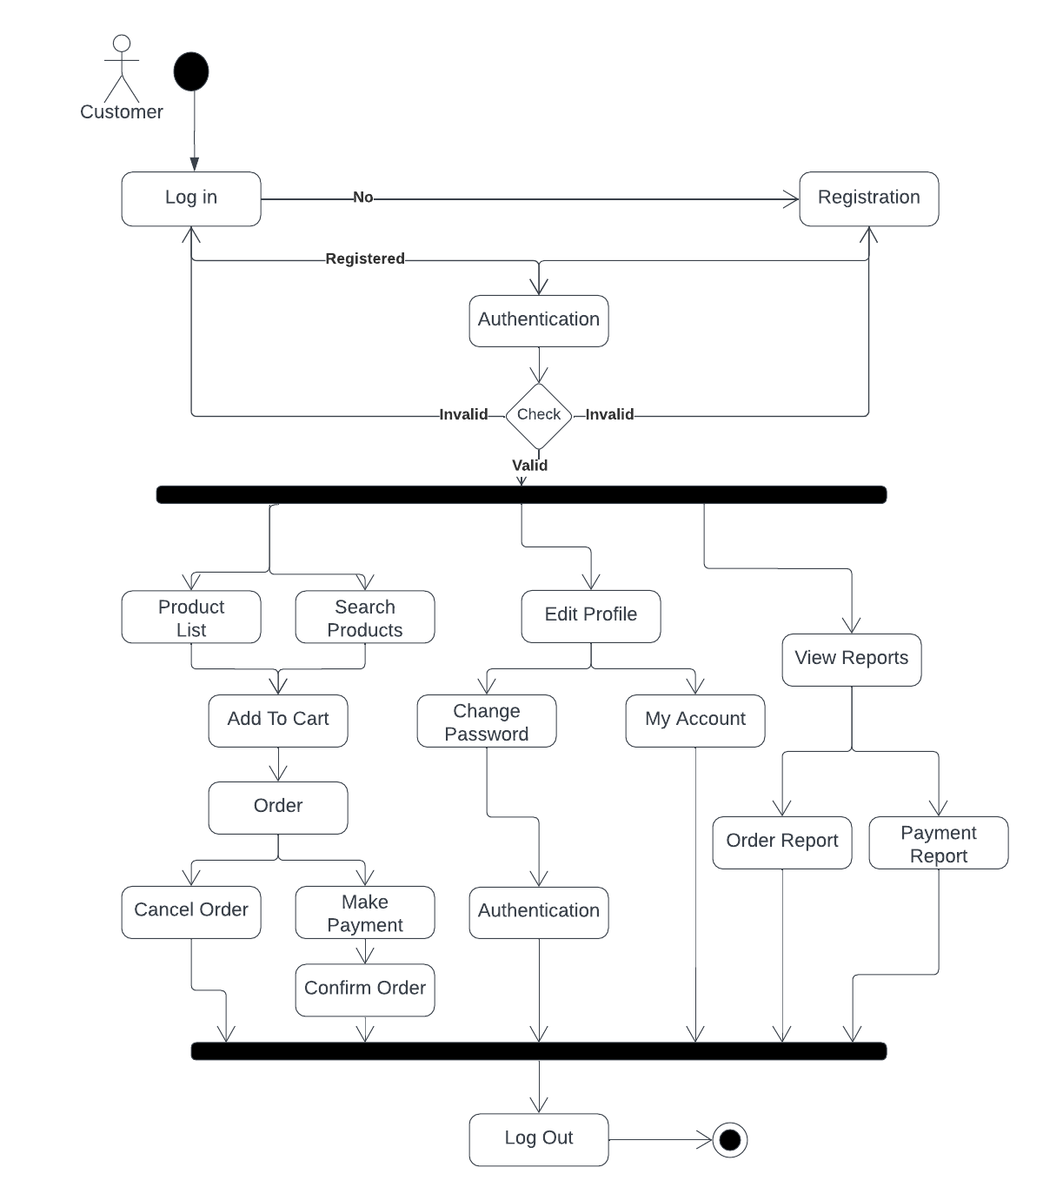

**For Admin**

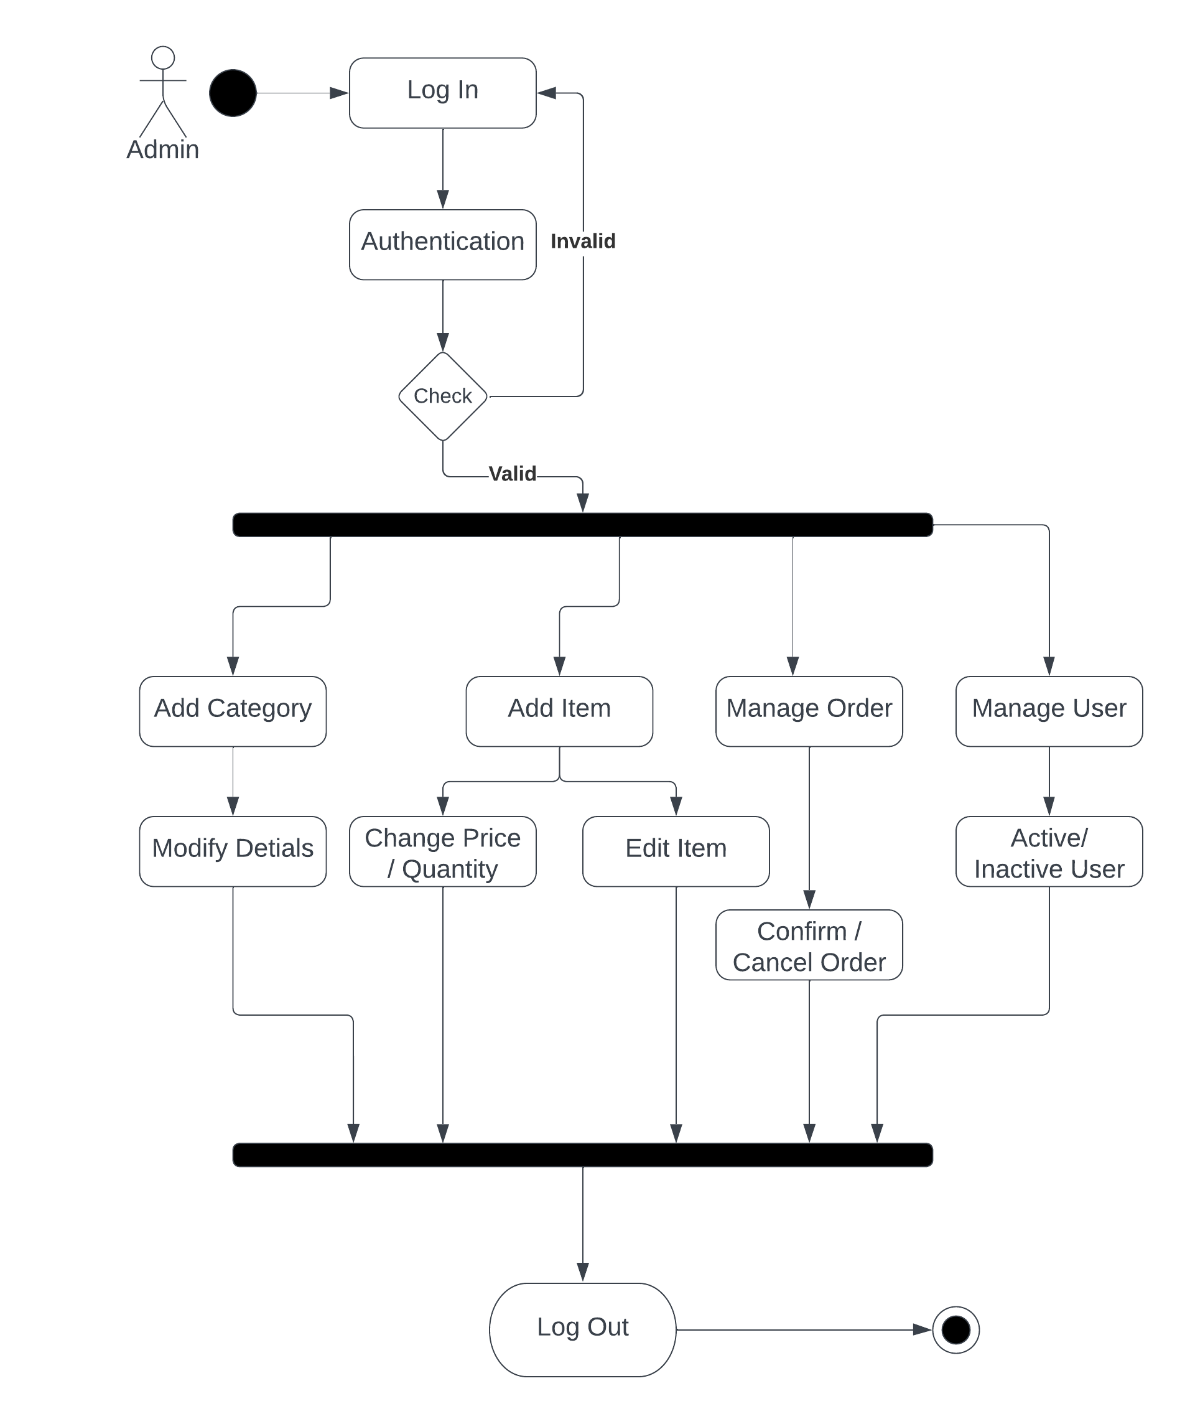

# **High Level Architectural System Design**

## **Component Diagram**

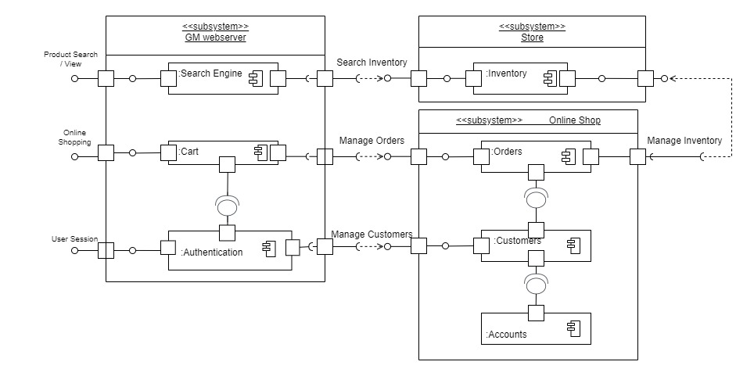

## **Deployment Diagram**

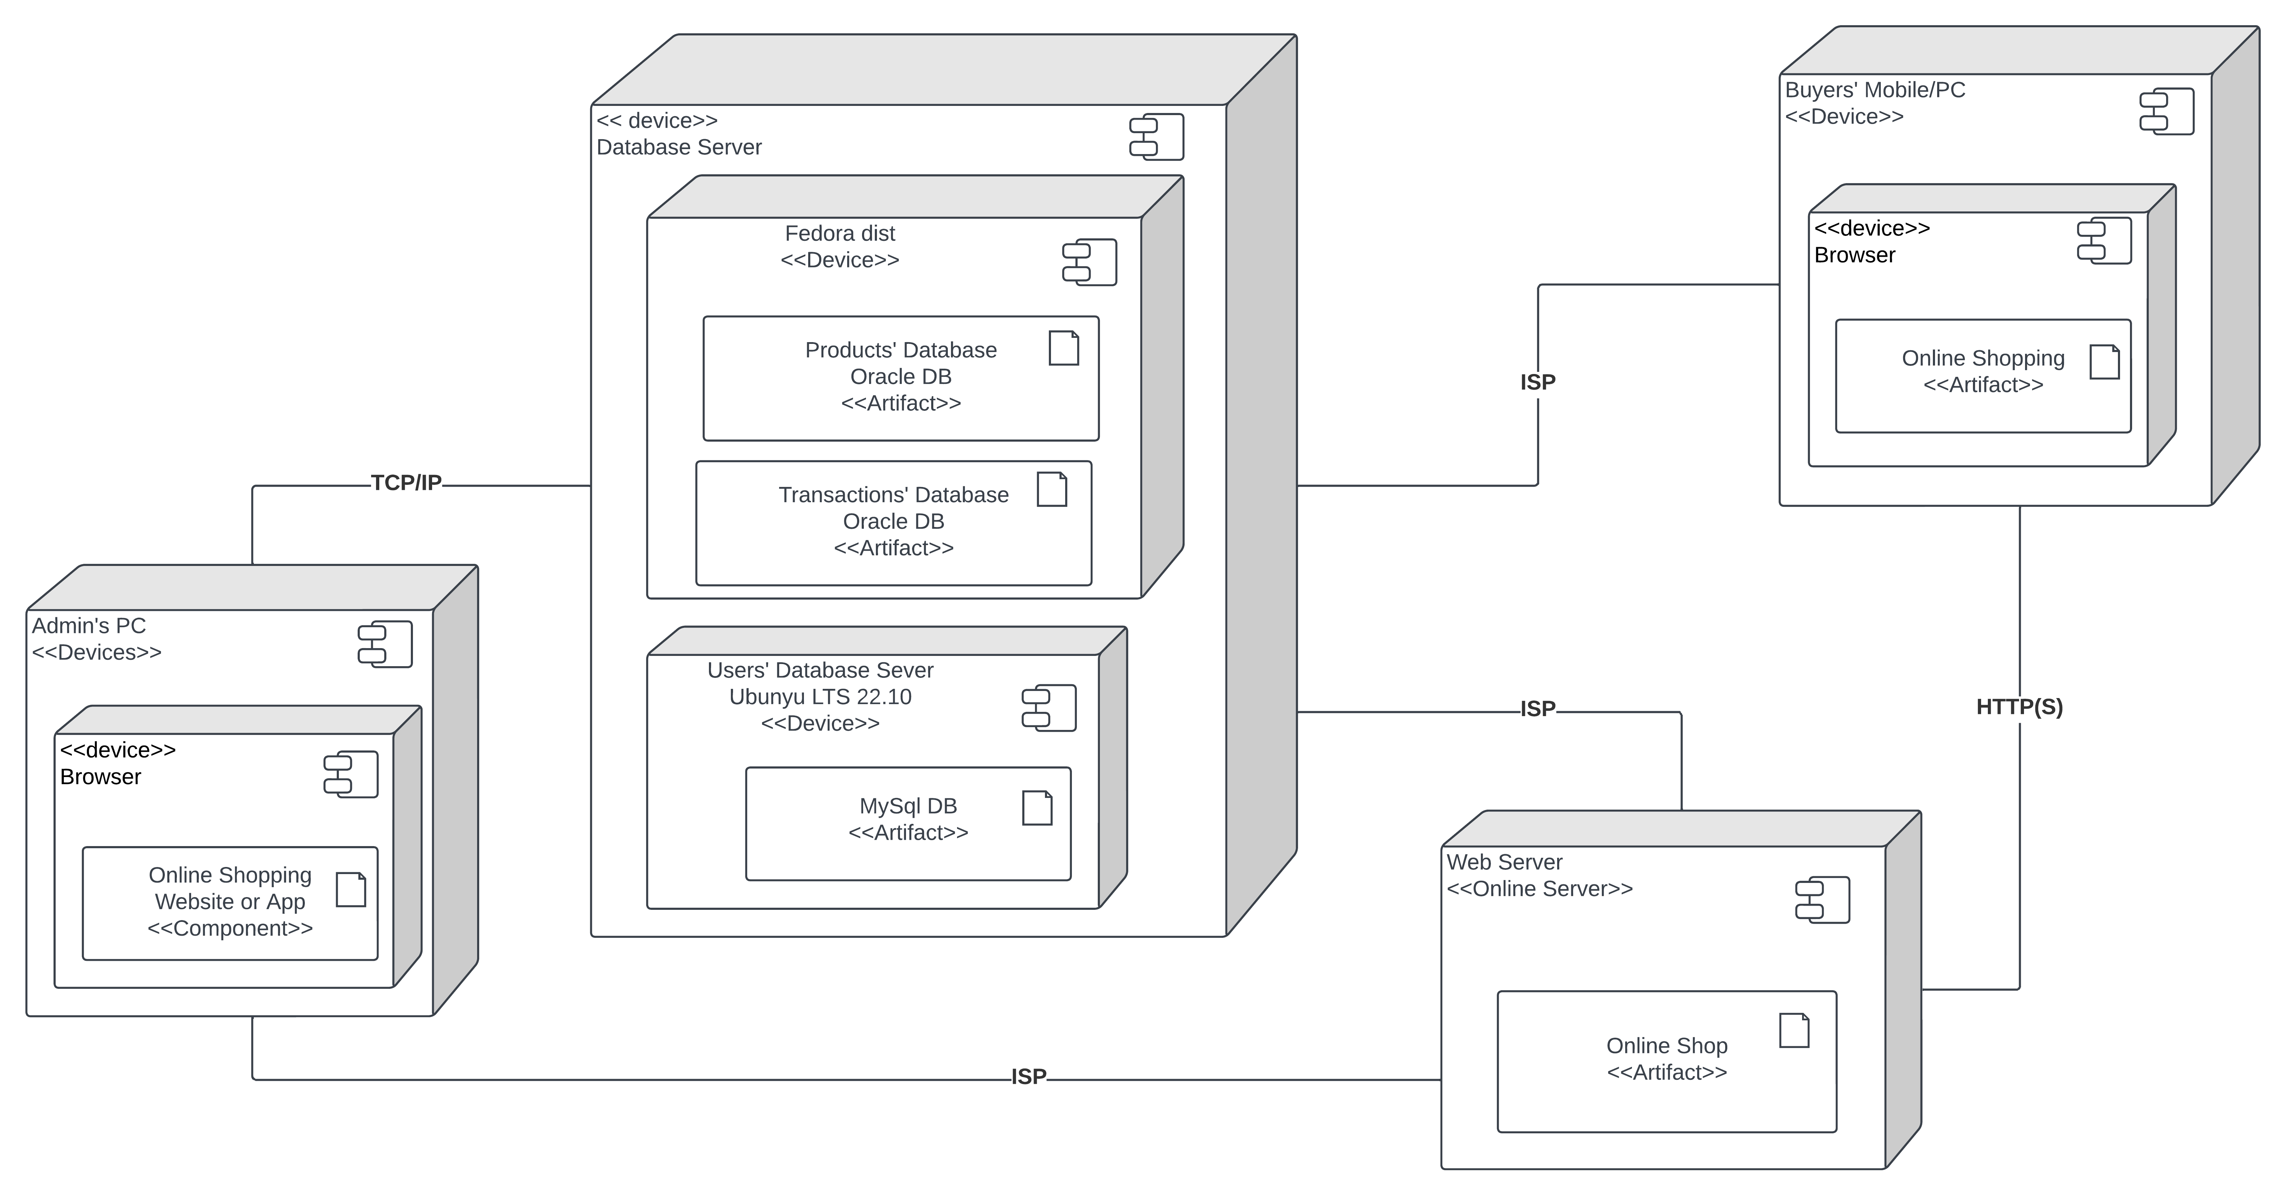

## **Package Diagram**

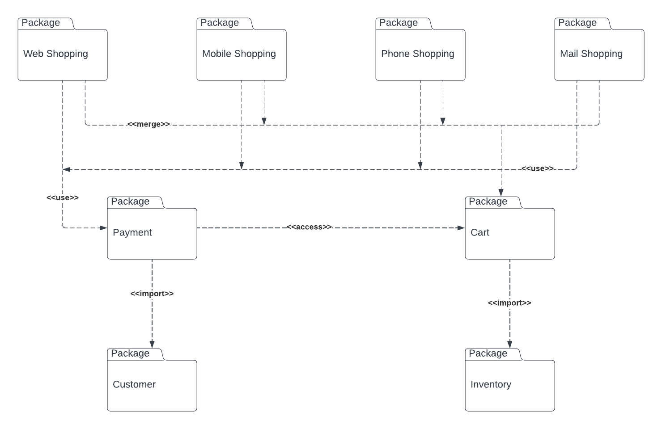

## **Future Enhancement**

With the technology currently available in our nation, it may be difficult for this system to reach its full potential and reach its highest depth. However, in the future, this system may add more payment and delivery options, enhance security procedures, maximize customer reach, expand its operational area from the domestic to the global level, and do much more. The development of technology will be seen in every phase as upgrades emerge periodically.

## **Conclusion**

The system has the potential to change the lives of millions of Ethiopians and serves as a beacon for the development of digital marketing. In time, the country may even expand more as a result of offering such solutions to such problems. That wraps up this project proposal, which we hope looks to be a good one.

## **Appendix**

* Higher quality pictures of diagrams are provided in a separate [**Images**](Images) folder.
* Links to Lucid chart Design Models are provided in the [**README.md**](README.md) File.
* A Demo Project Built Based on this System Design
* Link: <https://gm.bisry.me>
* Username: **user**
* Password: **123**
* Link: <https://gm.bisry.me/admin>
* Username: **admin**
* Password: **123**